**JENKINS**

**Prerequisites**

Jenkins requires Java7 or above to function. Java8 is recommended. Jenkins requires a fair amount of memory to operate well. Smaller installations should start around 256MB-1GB.

**Download and Install Jenkins**

1. Download Jenkins.exe file from the below location

<https://jenkins.io/index.html>

1. Click “Download” and select “window” option

D:\tools\ jenkins-2.32.1.zip

1. Unzip and extract the content to the directory of your choice.

D:\tools\jenkins.msi

1. Double click “Jenkins.msi” and select folder of your choice

D:\tools\Jenkins

1. Enter the default password available in the below directory

D:\Tools\Jenkins\secrets\initialAdminPassword

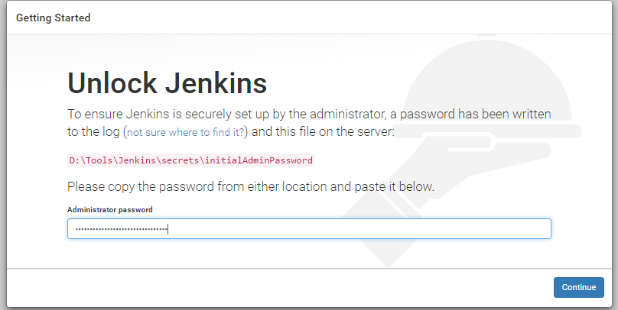

1. By default Jenkins will run in the port 8080

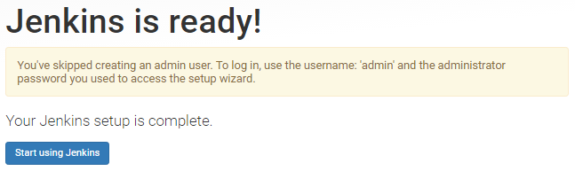

1. Make sure the Jenkins is working.

http://localhost:8080

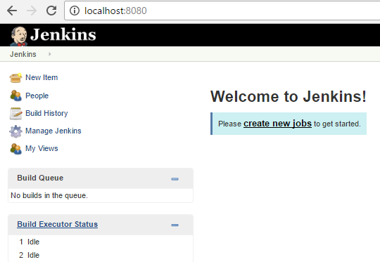

Successfully installed Jenkins !!!

**Note – To change the port , <installation-dir>/jenkins.xml**